## **Objectives**

* Define Props
* Explain Default Props
* Identify the differences between State and Props
* Explain reactDOM.render()

In this hands-on lab, you will learn how to:

* Use Props
* Apply reactDOM.render()

## **Prerequisites**

The following is required to complete this hands-on lab:

* Node.js
* NPM
* Visual Studio Code

## **Notes**

Estimated time to complete this lab: **60 minutes.**

Create a React Application named “shoppingapp” with a class component named “OnlineShopping” and “Cart”.

1. In Cart class, create 2 properties as mentioned below:

* Itemname
* Price

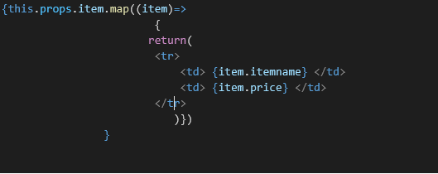

1. In OnlineShopping class, create an array of Cart and initialize 5 items.

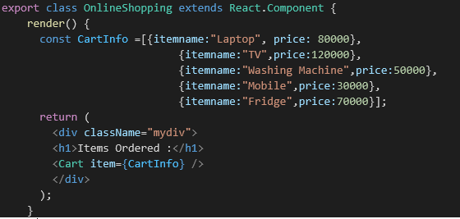

1. Loop through these items and display the data as shown below:

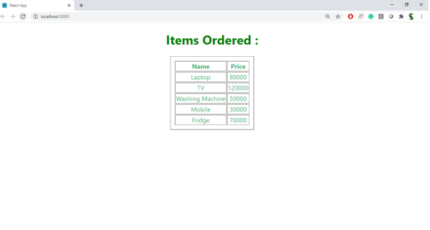

**Solution :**

npx create-react-app shoppingapp

cd shoppingapp

code .  
Step 2: Create Class Component Cart.js Inside src/Components/Cart.js:

import React, { Component } from 'react';

class Cart extends Component {

render() {

return (

<div style={{ marginBottom: '10px' }}>

<h3>{this.props.itemname}</h3>

<p>Price: ₹{this.props.price}</p>

</div>

);

}

}

export default Cart;

Step 3: Create Class Component OnlineShopping.js Inside src/Components/OnlineShopping.js:

import React, { Component } from 'react';

import Cart from './Cart';

class OnlineShopping extends Component {

render() {

const cartItems = [

{ itemname: 'Laptop', price: 55000 },

{ itemname: 'Smartphone', price: 25000 },

{ itemname: 'Bluetooth Headphones', price: 3000 },

{ itemname: 'Smart Watch', price: 5000 },

{ itemname: 'Tablet', price: 18000 },

];

return (

<div>

<h2>Shopping Cart</h2>

{cartItems.map((item, index) => (

<Cart key={index} itemname={item.itemname} price={item.price} />

))}

</div>

);

}

}

export default OnlineShopping;

**Step 4: Update App.js**

Replace contents of src/App.js:

import React from 'react';

import './App.css';

import OnlineShopping from './Components/OnlineShopping';

function App() {

return (

<div className="App">

<OnlineShopping />

</div>

);

}

export default App;

**Step 5: Run the App**

npm start

Expected Output

Shopping Cart

Laptop

Price: ₹55000

Smartphone

Price: ₹25000

Bluetooth Headphones

Price: ₹3000

Smart Watch

Price: ₹5000

Tablet

Price: ₹18000